### **Lab Title: Introduction to Behave and BDD in Python**

#### **Lab Objective:**

* Learn the basics of BDD using the behave framework in Python.
* Understand the basics of Features, and steps that work with the Behave framework.
* Develop a few scenarios, steps, and features for behavior to run tests on.

#### **Prerequisites:**

* Basic knowledge of Python
* Visual Studio Code (or any preferred code editor)
* Python and pip installed on your machine
* Behave framework installed (Will be installed during the lab)
* Understanding the use of pip

**Introduction:**

This lab is here to provide you with good hands-on experience with beginner concepts of Behave and BDD. You will be able to understand the basics of BDD and behave whilst also expanding your knowledge of the programming language python. By the end of this lab you will have set up a beginner friendly behave project using Gherkin syntax, at the end you will execute a simple BDD test.

#### **What is Behave?**

Behave is a Python framework that is based on BDD (Behavior-Driven Development). It is designed to facilitate collaboration among developers, quality assurance teams, and non-technical stakeholders. Behave is a way to test code using a syntax called Gherkin, a natural language that is both human and also readable/writeable. This means that most if not all people can fluently read and write it as it is a simple language to understand. The framework promotes clear communication of requirements, this makes it a very powerful tool for creating maintainable and understandable tests in a development environment.

##### **Step 1: Project Setup**

* Open your code editor and make a new project directory.
* For the Directory File name it BDDLab just for lab purposes.
* 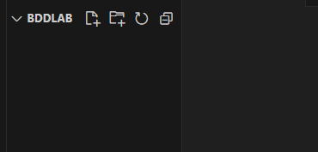

##### **Step 2: Install Behave**

* Install Behave using pip:
* 

##### **Step 3: Create Feature File**

* Inside the project directory, create a **features** directory.
* Inside the **features** directory, create a file named **my_features.feature**
* 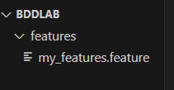
* Fill the inside of **my_features.feature** with this code
* 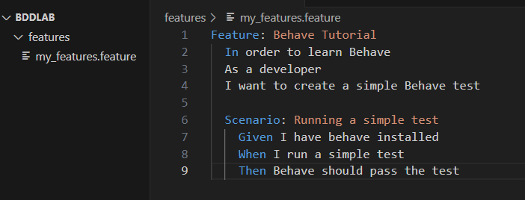

##### **Step 4: Create Step Definitions**

* Inside the project directory, create a **features/steps** directory.
* Inside the **features/steps** directory, create a Python file named **my_steps.py**
* 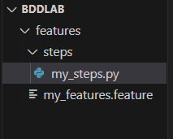
* Fill the inside of **my_steps.py** with this code
* 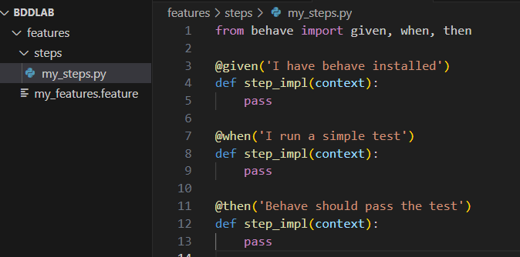

##### **Step 5: Run Behave**

* Ensure your virtual environment is still activated.
* Open the terminal in Visual Studio Code.
* Run Behave using the following command in the terminal:
* 

##### **Step 6: Verify Results**

Observe the output in the terminal. You should see that Behave discovers and executes your scenario successfully.

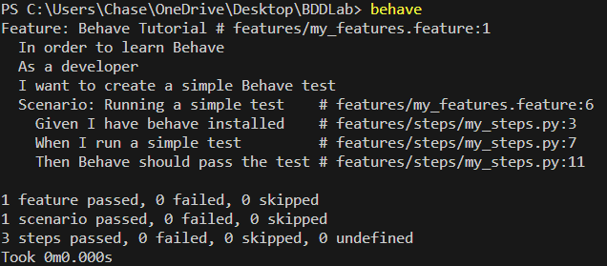

#### Conclusion:

#### Congrats! You have finished the lab, you should now have a basic understanding of the Python framework Behave and also Behavior Driven Development.